**SOFTWARE TESTING – CODING CONTEST : 1**

**Question 1:**

**Coding:**

package cc1;

import org.openqa.selenium.By;

import org.openqa.selenium.WebDriver;

import org.openqa.selenium.WebElement;

import org.openqa.selenium.chrome.ChromeDriver;

import org.openqa.selenium.chrome.ChromeOptions;

public class qn1 {

public static void main(String[] args) {

// TODO Auto-generated method stub

ChromeOptions co=new ChromeOptions();

co.addArguments("--remote-allow-origins=*");

WebDriver driver=new ChromeDriver(co);

driver.get("https://www.saucedemo.com/");

driver.manage().window().maximize();

WebElement user = driver.findElement(By.id("user-name"));

user.sendKeys("standard_user");

WebElement pass = driver.findElement(By.id("password"));

pass.sendKeys("secret_sauce");

WebElement login = driver.findElement(By.id("login-button"));

login.click();

driver.findElement(By.xpath("//*[@id=\"add-to-cart-sauce-labs-backpack\"]")).click();

String cartCount = driver.findElement(By.xpath("/html/body/div/div/div/div[1]/div[1]/div[3]/a/span")).getText();

driver.findElement(By.xpath("/html/body/div/div/div/div[1]/div[1]/div[3]/a")).click();

String product = "Sauce Labs Backpack";

driver.findElement(By.xpath("//*[@id=\"checkout\"]")).click();

driver.findElement(By.xpath("//*[@id=\"first-name\"]")).sendKeys("ABCD");

driver.findElement(By.xpath("//*[@id=\"last-name\"]")).sendKeys("X");

driver.findElement(By.xpath("//*[@id=\"postal-code\"]")).sendKeys("12345");

driver.findElement(By.xpath("//*[@id=\"continue\"]")).click();

System.out.println("Name of the product: " + driver.findElement(By.xpath("/html/body/div/div/div/div[2]/div/div[1]/div[3]/div[2]/a/div")).getText());

System.out.println("Price of the product: " + driver.findElement(By.xpath("/html/body/div/div/div/div[2]/div/div[1]/div[3]/div[2]/div[2]/div")).getText());

}

}

**Pom.xml:**

<project xmlns="http://maven.apache.org/POM/4.0.0" xmlns:xsi="http://www.w3.org/2001/XMLSchema-instance" xsi:schemaLocation="http://maven.apache.org/POM/4.0.0 https://maven.apache.org/xsd/maven-4.0.0.xsd">

<modelVersion>4.0.0</modelVersion>

<groupId>SKCET</groupId>

<artifactId>Pro1</artifactId>

<version>0.0.1-SNAPSHOT</version>

<dependencies>

<!-- https://mvnrepository.com/artifact/org.seleniumhq.selenium/selenium-java -->

<dependency>

<groupId>org.seleniumhq.selenium</groupId>

<artifactId>selenium-java</artifactId>

<version>4.9.0</version>

</dependency>

<!-- https://mvnrepository.com/artifact/io.github.bonigarcia/webdrivermanager -->

<dependency>

<groupId>io.github.bonigarcia</groupId>

<artifactId>webdrivermanager</artifactId>

<version>5.3.2</version>

</dependency>

</dependencies>

</project>

**Output:**

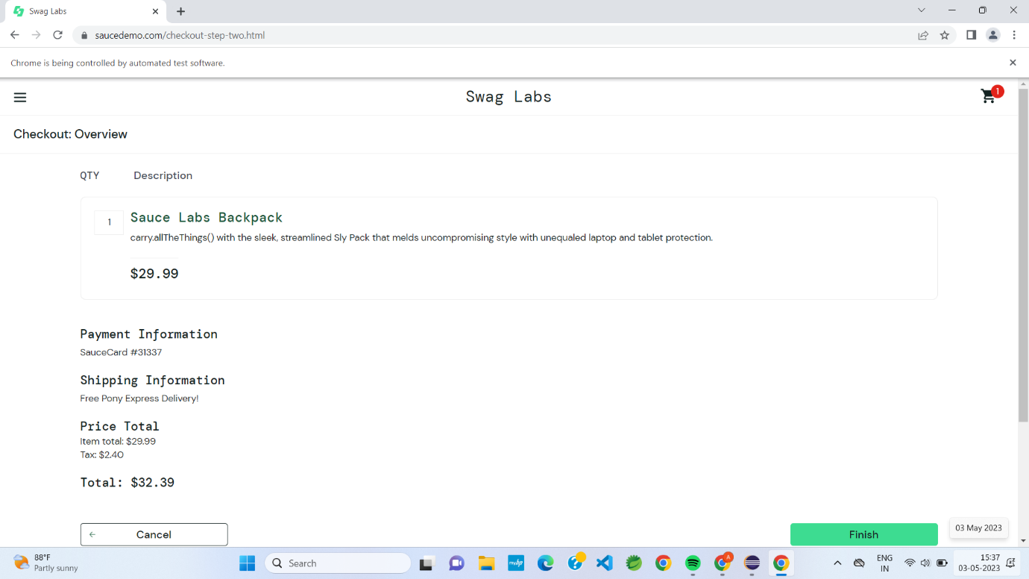

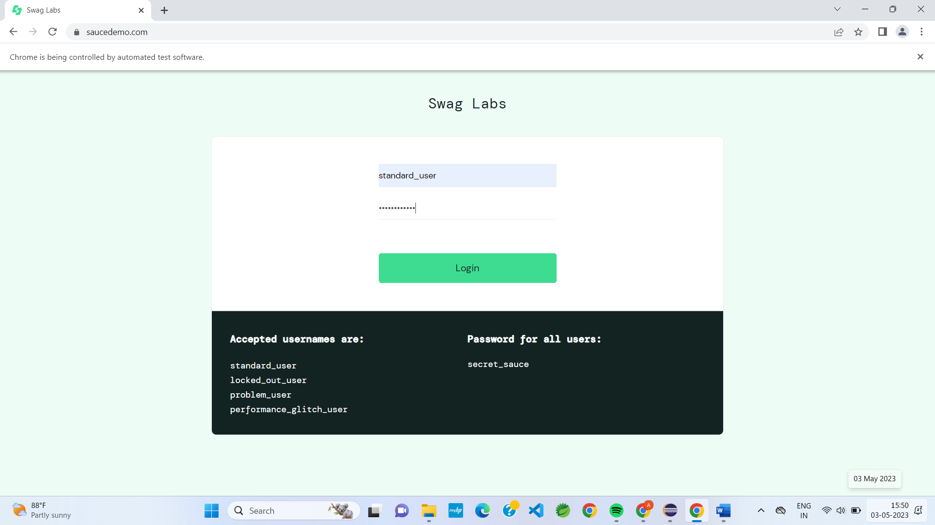

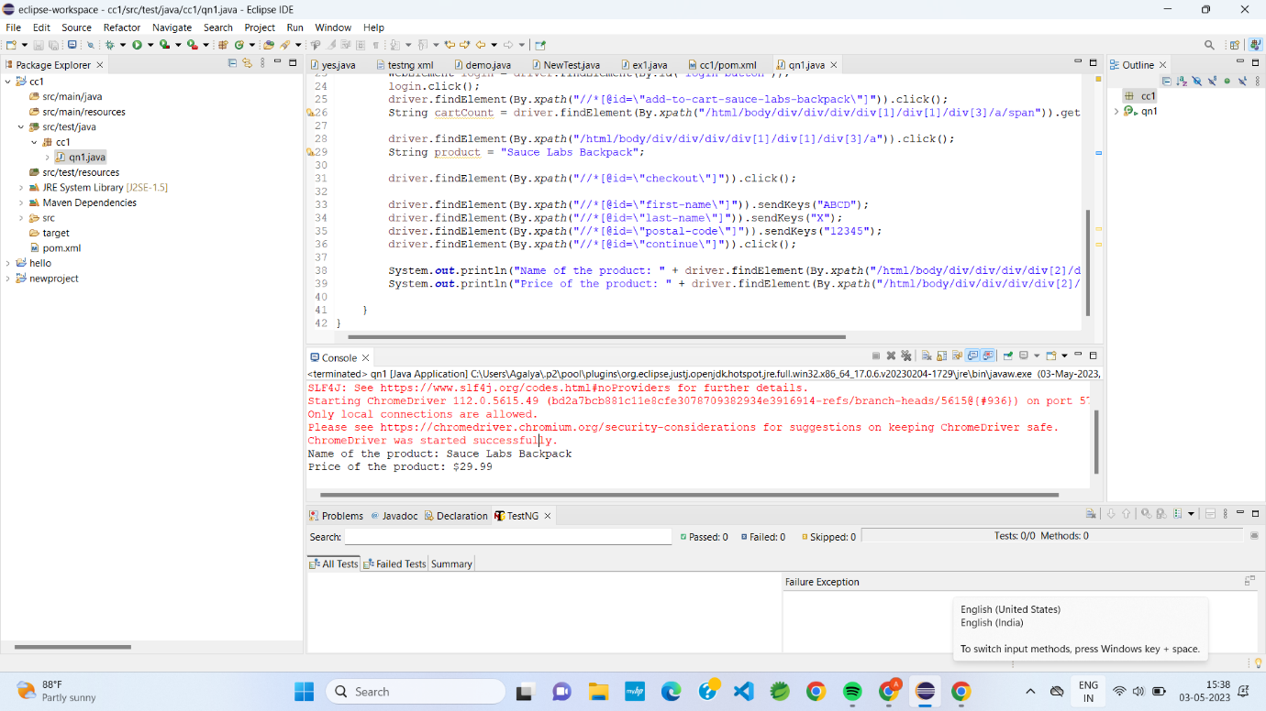

**Question 02:**

**Coding:**

package cc1;

import org.openqa.selenium.By;

import org.openqa.selenium.WebDriver;

import org.openqa.selenium.WebElement;

import org.openqa.selenium.chrome.ChromeDriver;

import org.openqa.selenium.chrome.ChromeOptions;

import io.github.bonigarcia.wdm.WebDriverManager;

public class cc1ques2 {

public static void main(String[] args) throws InterruptedException {

// TODO Auto-generated method stub

ChromeOptions co=new ChromeOptions();

co.addArguments ("--remote-allow-origins=*");

WebDriverManager.chromedriver().setup ();

WebDriver driver=new ChromeDriver(co);

driver.get ("https://www.saucedemo.com/");

driver.manage().window().maximize() ;

WebElement txtBoxl=driver.findElement(By.xpath("//*[@id=\"user-name\"]"));

txtBoxl.sendKeys("standard_user");

WebElement txtBox2=driver.findElement(By.xpath("//*[@id=\"password\"]"));

txtBox2.sendKeys("secret_sauce");

driver.findElement(By.xpath("//*[@id=\"login-button\"]")).click();

String txt1=driver.findElement(By.xpath("//*[@id=\"item_4_title_link\"]/div")).getText();

System.out.println(txt1);

driver.findElement(By.xpath("//*[@id=\"header_container\"]/div[2]/div/span/select")).click();

driver.findElement(By.xpath("//*[@id=\"header_container\"]/div[2]/div/span/select/option[2]")).click();

String txt2=driver.findElement(By.xpath("//*[@id=\"item_3_title_link\"]/div")).getText();

System.out.println(txt2);

System.out.println("filter (A-Z and Z-A) used smoothly");

driver.findElement(By.xpath("//*[@id=\"header_container\"]/div[2]/div/span/select")).click();

driver.findElement(By.xpath("//*[@id=\"header_container\"]/div[2]/div/span/select/option[3]")).click();

String txt3=driver.findElement(By.xpath("//*[@id=\"inventory_container\"]/div/div[1]/div[2]/div[2]/div")).getText();

System.out.println(txt3);

driver.findElement(By.xpath("//*[@id=\"header_container\"]/div[2]/div/span/select")).click();

driver.findElement(By.xpath("//*[@id=\"header_container\"]/div[2]/div/span/select/option[4]")).click();

String txt4=driver.findElement(By.xpath("//*[@id=\"inventory_container\"]/div/div[1]/div[2]/div[2]/div")).getText();

System.out.println(txt4);

System.out.println("filter (low price- high price and high price - low price )used smoothly");

Thread.sleep(5000);

}

}

**Output:**

